Figure-1.5. Simulation results

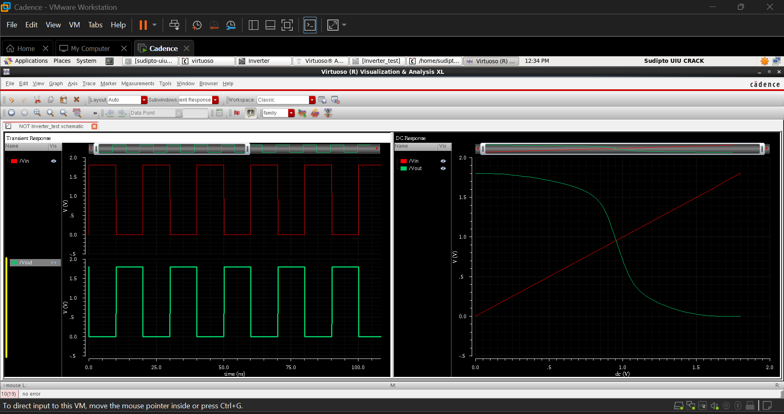

Figure-1.2. Complete transistor-level schematic of the CMOS (inverter)
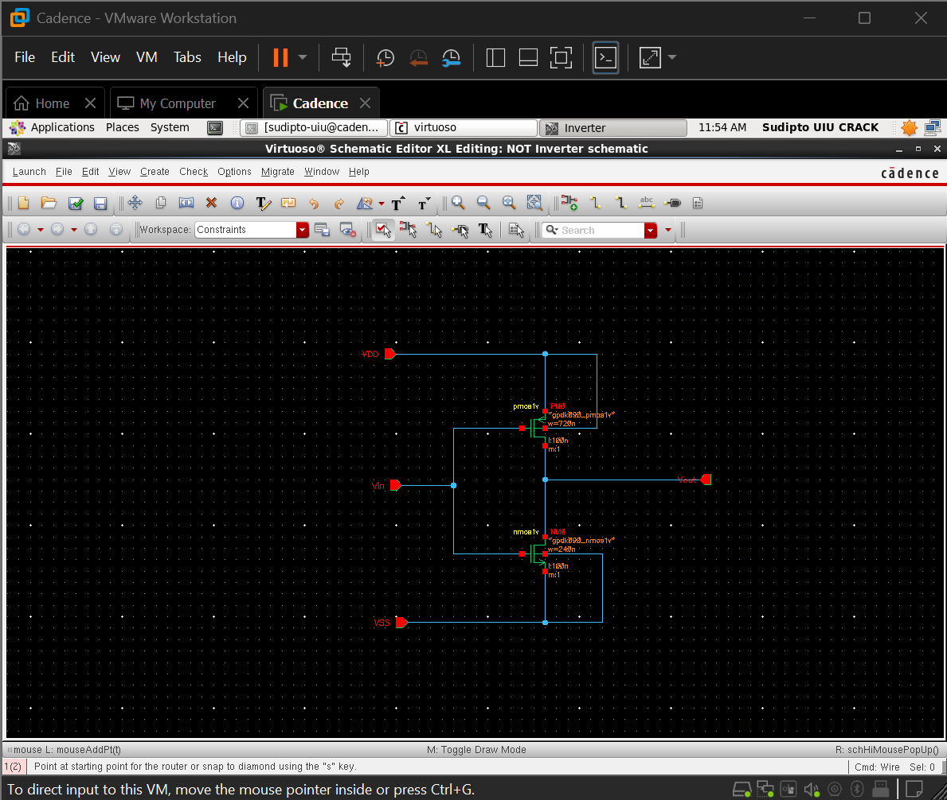

Figure-1.4. Test bench schematic (inverter_test)
